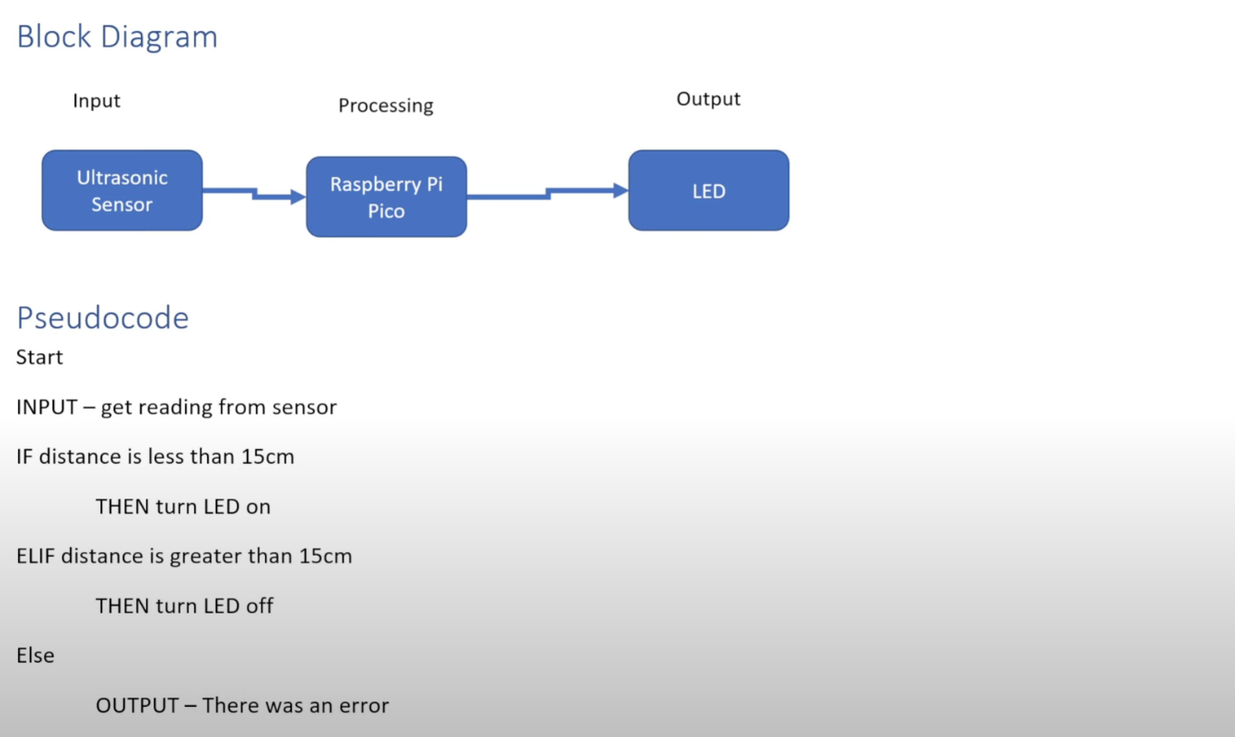**End/Stop**  
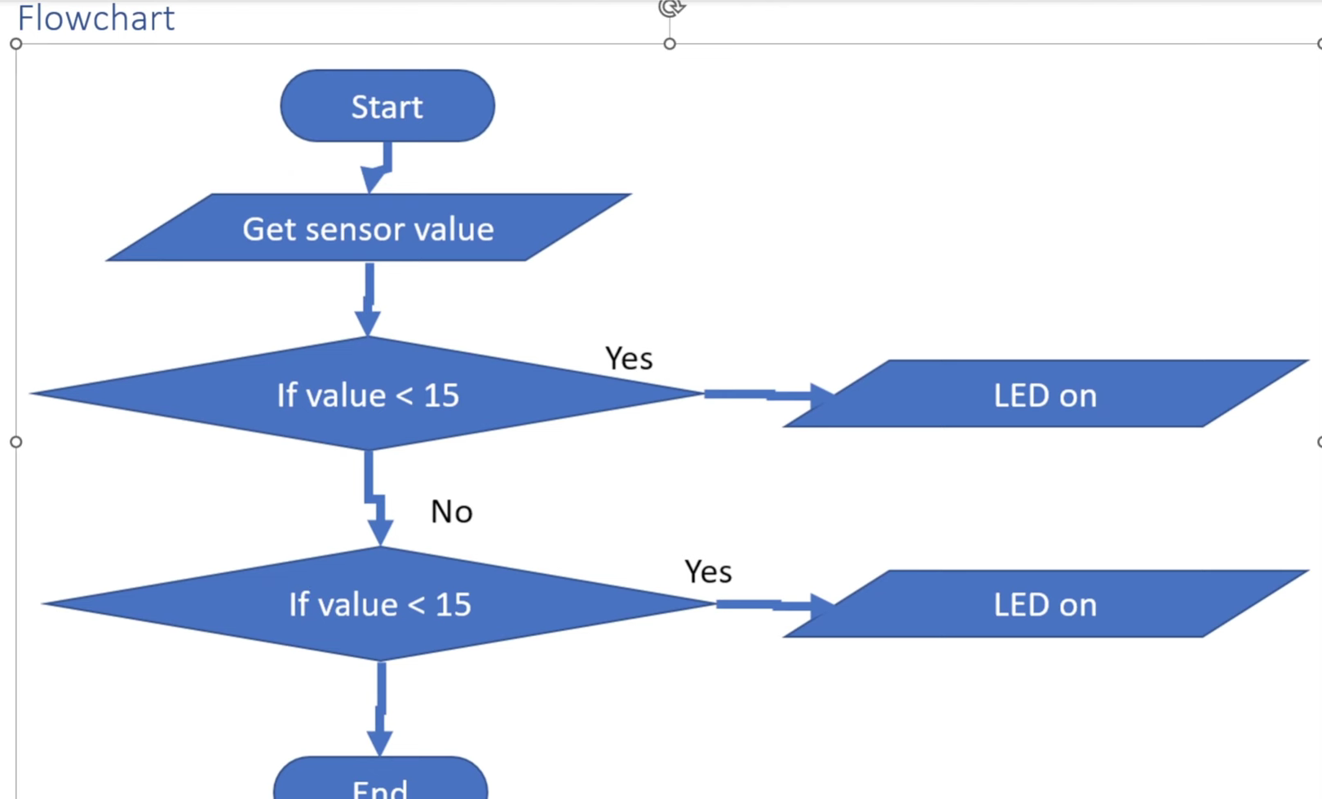

**Circuit**

**Description**

**LED**

Pin 3 from the Pico -> cathode of the LED

Pin 21 from the Pico -> 330 Ohm Resistor -> anode of the LED

**Ultrasonic Sensor**

Pin 40 from the Pico -> VCC of the sensor

Pin 3 from the Pico -> Ground of the sensor

Pin 19 from the Pico -> Trigger of the sensor

Pin 20 from the Pico -> Echo of the sensor

**Code**

from machine import Pin

import utime

#Declaration

trigger = Pin(16. Pin.OUT)

echo = Pin(17, Pin.IN)

del ultra():

    trigger.low()

    utime.sleep_us(2)

    trigger.high()

    utime.sleep_us(5)

    trigger.low()

    while echo.value() == 0:

        signaloff = utime.tick_us()

    while echo.value() == 1:

        signalon = utime.tick_us()

    timepassed = signalon - signaloff #Calculate the on and off signal

    distance = (timepasses * 0.0343) / 2 #Calculate the distance - speed of sound?

    print("Object at", distance, "cm")

    if distance < 15:

        led.high()

    else:

        led.low()

while True:

    ultra()

    utime.sleep(1)